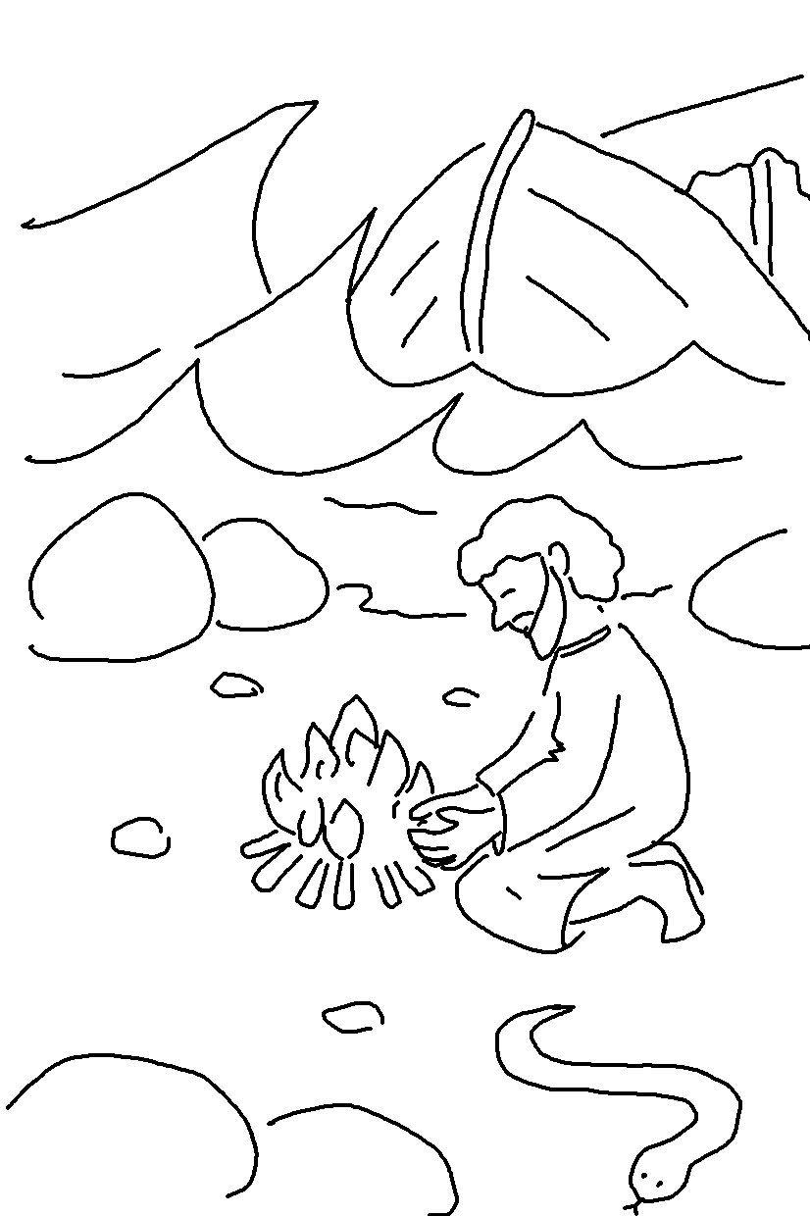
The Lord _ _ _ _ _ His people when they call to Him for _ _ _ _.
He _ _ _ _ _ _ _ them from all their troubles. Psalms 34:17_{NLT}

